2nd International E- Conference on New Normal in Education 2021
Igniting Minds Beyond the New Norms
21 & 22 August 2021

EXTENDED ABSTRACT TEMPLATE

TITLE
Author¹, Author² , Author³ (Times New Roman, 12)
¹Affiliation
email
²Affiliation
Email
³Affiliation
email

Received: date
Accepted: (leave blank)
Published: (leave blank)

ABSTRACT (Times New Roman, 12 Font Size, CAPITALIZE, BOLD, Align Left)- Abstract should be written in not more than 250 words and with 11 font size, Times New Roman, justified, single line spacing. Objectives, methods and findings are summarized in this section.

Keywords: Maximum 5 words

1. INTRODUCTION (Main Heading, 12pt Font, Bold, Font Style: Times New Roman)

The introduction section should present the scope, problem statement and objective of the paper. It may also briefly review the relevant literature related to the work, describe the methods, and provide an overview of the main results of the work. (Times New Roman, 11pt font, single-spacing and justified). The extended abstract should be prepared on an A4-sized paper with 25 mm margins on all sides and typed with single spacing using size 12 Times New Roman font. All illustrations must be designed inside of the main text.

The introduction includes a brief description of the background of the work/project/innovation/invention, related past studies, and the objective of the study. It may also include the problem statement (if any) that lead to the idea/work.

Extended abstracts should be around 2 to 5 pages, including the references, and no numbering for the pages. Use proper in-text/end-text citation according to APA style.

2. METHODS (Main Heading, 12pt Font, Bold, Font Style: Times New Roman)

The methodology must be clearly stated and described in sufficient detail or with adequate references.

3. RESULTS AND DISCUSSION (Main Heading, 12pt Font, Bold, Font Style: Times New Roman)

The findings and arguments of the work should be explicitly described and illustrated. Supporting with the figures, tables and images of the results (if any).

3.1: Subtitle (Time New Roman, Bold, 12pt)

All of the tables, images and figures should be centred. Figures and images should be numbered together (Figure 1) and figure caption should be placed under the figure or image. The table should also be numbered (Table 1) and the table header should be placed at the top of the table. Table, image, and figure headers should be written with upper case initial letters, bold, and cantered. References (if any) of the tables, figures and images should be presented just under the tables, figures and images in the form of author surname and publication date.

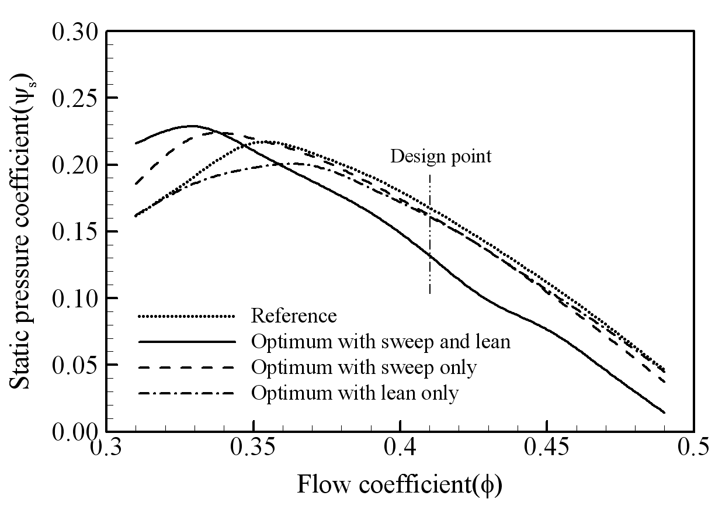
Figure 1. Figure title

3.2: Subtitle (Time New Roman, Bold, 12pt)

Authors are advised to prepare their figures in either black and white or colour. Please prepare the figures in high resolution (300 dpi) for half-tone illustrations or images. Pictures must be sharp enough and clear. Figures must be originals, computer-generated or drafted, and placed within the text area where they are discussed. Figure 1 shows one example. Figure captions should be in 10pt “Time News Roman” font, bold, centred. When applicable, the texts in graphs, illustrations or images should be set in 8pt “Time News Roman” font.

5. CONCLUSION (Main Heading, 12pt Font, Bold, Font Style: Times New Roman)

Conclusions should include (1) the principles and generalisations inferred from the results, (2) any exceptions to or problems with these principles and generalisations, (3) theoretical and/or practical implications of the work, and (4) conclusions drawn and recommendations.

ACKNOWLEDGEMENT (Main Heading, 12pt Font, Bold, Font Style: Times New Roman)

The authors would like to express appreciation for the support of the sponsors [Project Number = XXXXXXX] (if any).

REFERENCES (Main Heading, 12pt Font, Bold, Font Style: Times New Roman)
The total no. of references must not exceed 15. References should be listed alphabetically and presented according to the APA Style.

Author, A. A., Author, B. B., & Author, C. C. (Year). Title of article. Title of Periodical,
volume number (issue number), pages. https://doi.org/xx.xxx/yyyy

Examples:

An Article:
Mahazril, A.Y., S., (2021). Assessing the housing preferences among young civil servants in Malaysia, International Journal of Housing Market and Analysis, 28, 7, 1188-1200. https://doi.org/xx.xxx/yyyy

Worthington, T. A. (2018). Letting Students Control Their Own Learning: Using Games, Role-Plays, and Simulations in Middle School U.S. History Classrooms. The Social Studies, 109(2), 136–150. doi:org/xxx.xxx/yyyy

Online Newspaper Articles:
Adelene, E. (2021, August 27). The Union in the limelight. The New Straits Times. Retrieved from……………………………..

Technical and Research Reports (often with corporate authors):
Khazanah Research Institute. (2020, March 15). 2020 Annual Report. Retrieved from ……………

Chapters in Edited Books
Boli-Bennett, J. (1979). The ideology of expanding state authority in national constitution 1870-1970. In J. W. Meyer & M. T. Hannan (Eds.), National development and the world system: Educational, economic, and political change (pp. 1950-1970). University of Chicago Press.

